# Report Option B - Task 1: Setup

1. **Environment Setup Summary:**

I use Anaconda to setup virtual environment and download the libraries needed for the assignment

1. **Requirements Installation**:

The requirements.txt file or manual installation via pip was needed for the following packages:

* 1. **Numpy**: pip install numpy
  2. **Matplotlib**: pip install matplotlib
  3. **Pandas**: pip install pandas
  4. **TensorFlow**: pip install tensorflow
  5. **Scikit-learn**: pip install scikit-learn
  6. **Pandas-Datareader**: pip install pandas-datareader
  7. **Yfinance**: pip install yfinance

These packages provide essential functionality for numerical computations, data manipulation, machine learning model creation, and accessing financial data.

1. **Testing the Provided Code Bases:**
   1. **Summaries of your attempts to test the provided code bases (v0.1 and P1) with screenshots**

**Step1: Open Anaconda  
**

**Step3: Run VSCode on Anaconda**

**Step4: Open terminal and install all library requires**

**Step5: Run code in terminal**

**V1:**

**P1:**

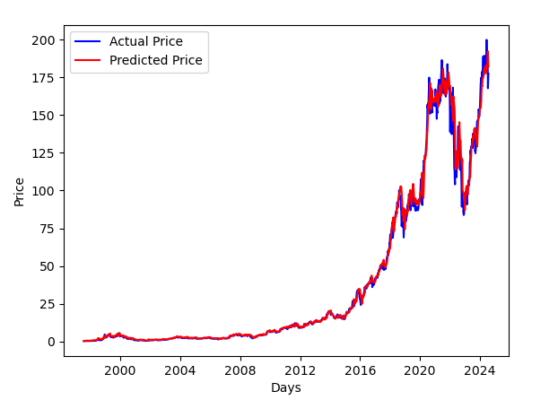

1. **Understanding the Initial Code Base (v0.1):**

* **Code Summary**:s
  + The provided code is designed to predict stock prices using a Long Short-Term Memory (LSTM) neural network. The process begins by loading historical stock data using the yfinance library. The data is then preprocessed through scaling, and an LSTM neural network model is set up using TensorFlow's Keras API. The model is trained on the scaled data and used to make predictions on test data, which are then visualized.

**Key Components**:

* + - **Data Loading**: The code utilizes the yfinance library to download historical stock prices for a specified company (CBA.AX in this case) over a defined date range (2020-01-01 to 2023-08-01 for training and 2023-08-02 to 2024-07-02 for testing).
    - **Data Preprocessing**: The stock prices are scaled using MinMaxScaler to ensure that the data is normalized for the neural network.
    - **Model Architecture**: An LSTM network with multiple layers, dropout for regularization, and a dense layer for output is used to predict future stock prices.
    - **Training**: The model is trained on the historical data for a specified number of epochs.
    - **Prediction and Visualization**: After training, the model is used to predict stock prices on the test data. The results are visualized using matplotlib, with a plot that shows both the actual and predicted stock prices, allowing for a visual comparison of the model’s performance.